**Project Title: Baking Website**



Project Done by: S . Nainammal

OCT2nd Batch PGFSD

**Project Overview**: Create an engaging and informative website dedicated to the world of baking. The website, named "BH" will serve as a one-stop destination for baking enthusiasts, from beginners to experienced bakers, offering a wide range of resources, recipes, tutorials, and a thriving baking community. The website's primary goal is to inspire and educate individuals who have a passion for baking, making it easy for them to explore, learn, and share their baking experiences.

**The objective of a baking website**

**Customized Cakes:**

We take immediate orders on customized cakes order as well. In case you want midnight cake delivery In Chennai, call our customer care support and inform them about the custom cake that you want to be delivered. We make sure that we meet your expectations entirely and bring cheer to your face with timely delivery.

**Send Best Designer Cakes Online Through BH:**Designer cakes are our pride and joy at FNP. We have a plethora of designer cakes that are ideal for people of different age groups and with different tastes. If you are searching for a designer cake for a special occasion, check out our lovey-dovey Valentine’s Day, adorable Mother’s Day, funky Children’s Day and sparkly cakes for New Year. These cakes are made keeping the tone of the celebrations in mind. Other than occasion-themed cakes, we also offer cartoon cakes and personalised photo cakes. The Kicking Po cake is for Kung Fu fans. This cake is available in 2 Kilograms and arrives in 4 flavours namely Chocolate, Butterscotch, Pineapple and Vanilla. The mouth-watering batman cake from FNP is any little boy's fantasy

**Share Recipes:** Provide a platform for sharing baking recipes with detailed instructions, ingredients, and photos.

**Inspire and Educate:** Inspire baking enthusiasts and educate them about different baking techniques, ingredients, and tools.

**Build a Community:** Foster a community of bakers where they can interact, share their experiences, and ask questions.

**Promote Products:** If you sell baking-related products or equipment, the website can serve as a platform to showcase and promote your products.

**Improve Baking Skills**: Offer tutorials, tips, and resources to help bakers of all skill levels improve their abilities.

**Local Baking Community:** Connect bakers in a specific geographical area or region and promote local events, classes, or meetups.

**Project Scope:**

* Create a user-friendly and engaging baking website called "BakeDelights" that caters to baking enthusiasts of all skill levels.
* Offer a wide range of baking resources, recipes, tutorials, and a platform for the baking community to connect and share their experiences.
* Promote and inspire the love of baking, making it accessible to a broader audience.
* Ensure the website is informative, visually appealing, and easily navigable.
* Potential e-commerce integration to sell baking-related products and generate revenue.

**Real-time usability:**

* **Interactive Cooking Timers**: Incorporate interactive timers that users can set while following a recipe. These timers can provide real-time alerts for different baking stages, such as preheating the oven, mixing, or baking times.
* **Live Chat or Support**: Offer a real-time chat or support feature where users can ask questions and get immediate assistance from baking experts or community members. This can be particularly useful for troubleshooting issues or clarifying recipe instructions.
* **User-Generated Content Updates**: Allow users to share their baking experiences and updates in real-time. For example, users could post photos and descriptions of their baking projects, creating a live feed of community engagement.
* **Ingredient Substitution Suggestions**: Provide real-time suggestions for ingredient substitutions. If a user is missing a particular ingredient, the website can offer alternatives that can be used for a similar effect in the recipe.
* **Inventory Tracking**: Offer a feature where users can create and manage their baking ingredient inventory. The website can provide real-time alerts when ingredients are running low and even generate shopping lists based on selected recipes.
* **Seasonal and Local Updates**: Incorporate real-time updates on seasonal ingredients and local events or promotions related to baking. Users can stay informed about the best ingredients to use at a given time and discover local baking classes or events.
* **Community Challenges and Competitions**: Organize real-time baking challenges or competitions that users can participate in. These events can have live leaderboards and real-time updates on participants' progress.
* **User-Generated Q&A:** Implement a real-time question and answer section where users can post questions about specific recipes or baking techniques. Other users or experts can respond promptly, creating a dynamic knowledge-sharing environment.
* **Live Cooking Demos and Workshops**: Host live streaming cooking demonstrations and workshops where users can interact with baking experts in real time. These events can be scheduled and announced in advance to encourage user participation.
* **Dynamic Search and Filter Options**: Provide dynamic search and filter functionalities that update in real-time as users input search criteria. This helps users quickly find recipes based on available ingredients or dietary restrictions.
* **Recipe Scaling**: Offer real-time recipe scaling options, allowing users to adjust ingredient quantities based on the number of servings they need. The website can automatically update ingredient amounts and baking times accordingly.
* **Notifications and Alerts:** Allow users to subscribe to recipe updates or website notifications, such as new recipes, blog posts, or upcoming events. These real-time alerts keep users engaged and informed about the latest content.

**Statistic reports :**

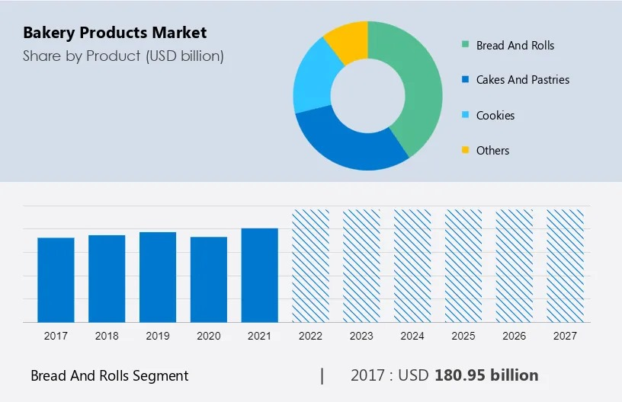

These Data shows the Growth of the Bakery Products Market

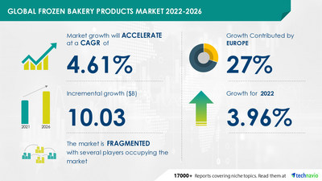

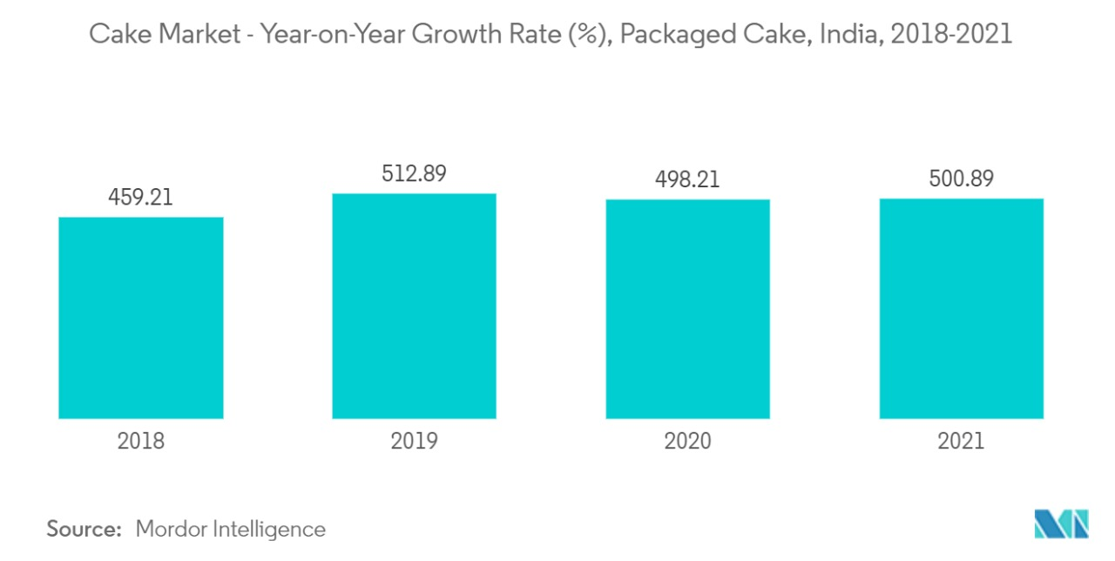

These Data shows the Growth of the Cake products

**Budget of the Project:**

* **Development Costs:**

Website Development: $5,000 - $15,000

Content Management System (CMS) Licensing/Subscription: $0 - $1,000

Web Hosting (annual): $100 - $500

Domain Registration (annual): $10 - $50

* **Design and Branding:**

Web Design and Layout: $1,000 - $5,000

Logo and Branding: $500 - $2,000

Stock Images/Graphics: $200 - $500

* **Content Creation:**

Recipe Development/Testing: $500 - $2,000

Professional Photography: $1,000 - $5,000

Content Writing: $1,000 - $3,000

* **Marketing and Promotion:**

SEO Services (if outsourced): $500 - $2,000 per month

Social Media Management (if outsourced): $500 - $2,000 per month

Advertising Budget (e.g., Google Ads, Facebook Ads): $500 - $2,000 per month

* **Community and Support:**

Community Moderators (if needed): $500 - $1,500 per month

Support Staff (if needed): $500 - $1,500 per month

* **E-commerce and Monetization (if applicable):**

Payment Gateway Setup: $100 - $500

E-commerce Functionality (if selling products): $1,000 - $5,000

* **Contingency:**

10-20% of the total budget for unexpected expenses: $2,000 - $6,000

* **Ongoing Costs (Monthly/Annual):**

Content Updates and Maintenance: $100 - $500 per month

Hosting and Domain Renewals: $150 - $550 per year

Marketing and SEO Costs (if outsourced): Varies

Total Estimated Budget Range: $12,000 - $30000

**Here are several ways to make a profit from your baking website:**

* **Advertising:** Display Ads: Utilize advertising networks like Google AdSense to display targeted ads on your website. You earn revenue based on ad impressions or clicks.
* **Affiliate Marketing:** Promote baking-related products and equipment through affiliate marketing programs. Earn a commission for each sale generated through your affiliate links. Share honest product reviews and recommendations to build trust with your audience.
* **Premium Content:** Offer premium or subscription-based content to your users. Provide access to exclusive recipes, advanced tutorials, or a members-only community in exchange for a monthly or yearly fee.
* **Online Courses and Classes:** Create and sell online baking courses, workshops, or classes. Offer both free and premium courses, and promote them to your audience.
* **eBook Sales:** Compile your best recipes and baking tips into eBooks that users can purchase and download. eBooks can be a valuable revenue stream.
* **Product Sales:** Sell your baking-related products, such as merchandise, baking tools, or specialty ingredients, directly through your website's e-commerce platform.
* **Coaching and Consultations:** Offer one-on-one or group coaching sessions for users who want personalized baking guidance or troubleshooting.
* **Sponsored Content:** Collaborate with baking brands for sponsored content. Write articles, create videos, or develop recipes that feature their products or services in exchange for compensation.
* **Email Marketing:** Build and nurture an email list of baking enthusiasts and offer paid newsletters or exclusive content to subscribers. Email marketing can be a valuable tool for driving sales.
* **Freelance Work and Services:** Promote your baking expertise and offer freelance services such as recipe development, food styling, or food photography to other businesses or individuals.
* **Event Promotion:** Promote and sell tickets for baking-related events, workshops, or classes, either online or in collaboration with local businesses.
* **Local Partnerships:** Partner with local bakeries, cafes, or businesses to promote their products or services to your website's audience in exchange for a commission or fee.
* **Merchandise Sales:** Create and sell branded merchandise, such as baking-themed apparel, kitchen gadgets, or accessories, to your website's visitors.
* **Celeb Club Membership**

Get 35% off on 5 orders of small cakes or 3 orders of large cakes.

Introductory offer : The Celeb Club Now for Rs. 299 instead of Rs. 599!.

Celebrate more! Save More!! With The Celeb Club

**Conclusion:**

To maximize profitability, it's crucial to focus on providing valuable, high-quality content, engaging your audience, and continuously improving your website's user experience. Additionally, consider a combination of these monetization strategies to diversify your income streams and reduce reliance on a single source. Remember that building a profitable baking website takes time, effort, and dedication, so be patient as your audience grows and your revenue increases.